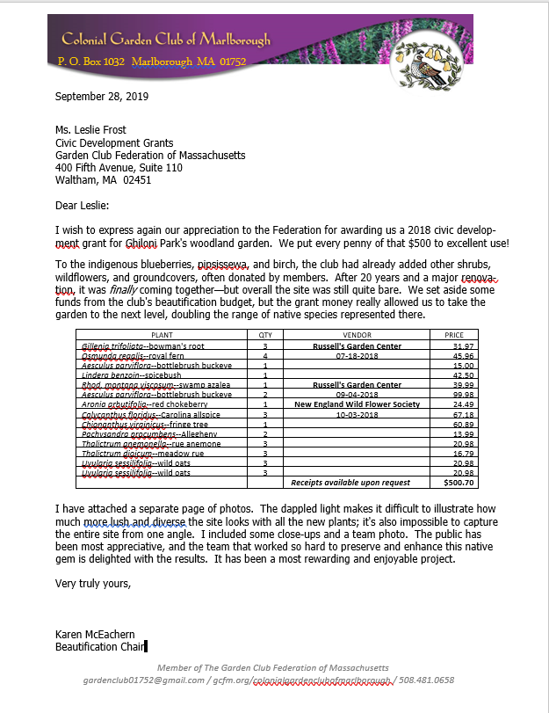

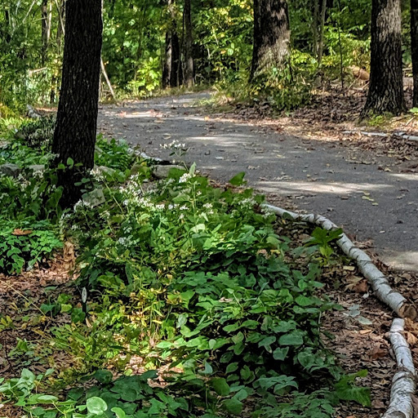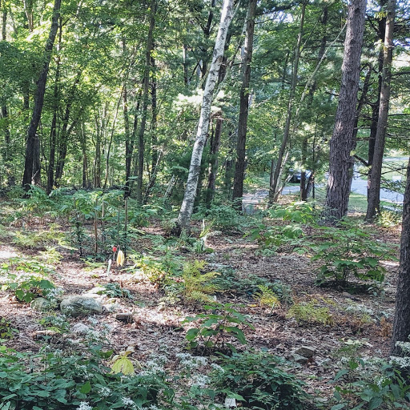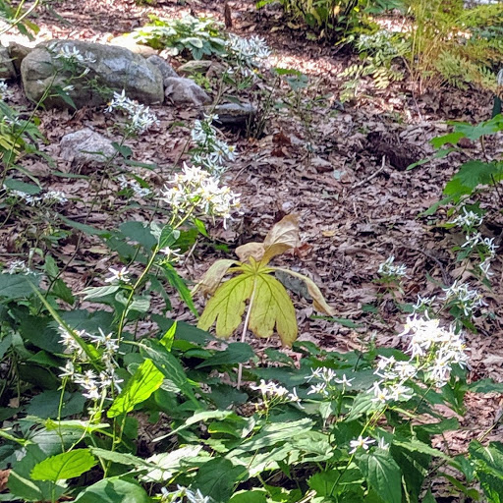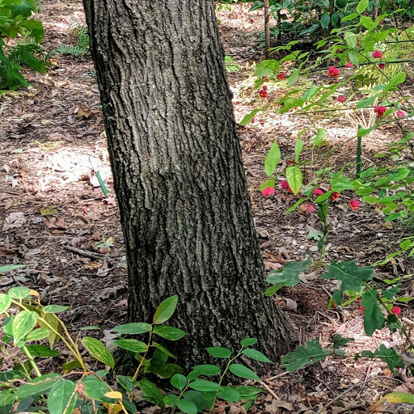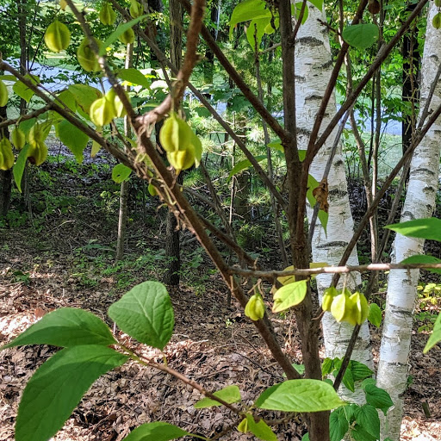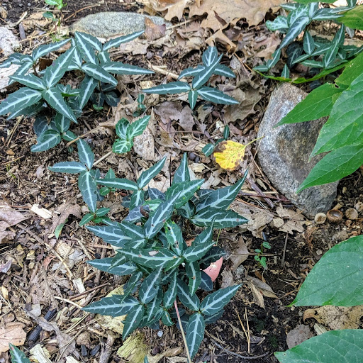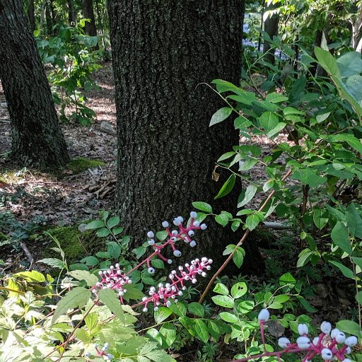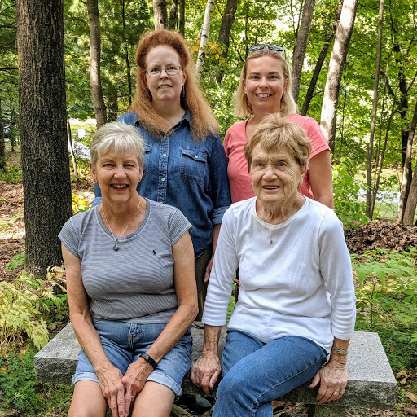

Oakleaf hydrangeas, Solomon's seal, royal ferns, jacks-in-the-pulpit, black cohosh, and other native plants thrive in the dappled shade and are spreading to fill in the garden. space.

The paved path is a popular walk for Marlborough residents.

White wood asters *(Eurybia divaricata)*

Hearts a-bustin' *(Euonymus americanus)* fruits

Carolina Silverbell's *(Halesia carolina)* winged drupes

Doll's Eyes *(Actaea pachypoda)* in their autumn glory

Pipsissewa *(Chimaphila maculata)*

The Woodland Garden Team, clockwise from back left: Karen McEachern, Deborah Jakubowski Russ,

Suzanne Brigham, Sue Dolesh. Absent: Sarah Douglas